



**C / C++ Programming**

**Lab # 01**

**Introduction to C & Debugger tools**

|  |  |
| --- | --- |
| **Name** | *Muddassir Ali Siddiqui* |
| **Instructor** | *Instructors Name based on each modules* |
| **Date** | *9th July 2025* |

1. **In-Lab Tasks: (***Write your lab task & screenshots here***)**
2. **Task 1:**

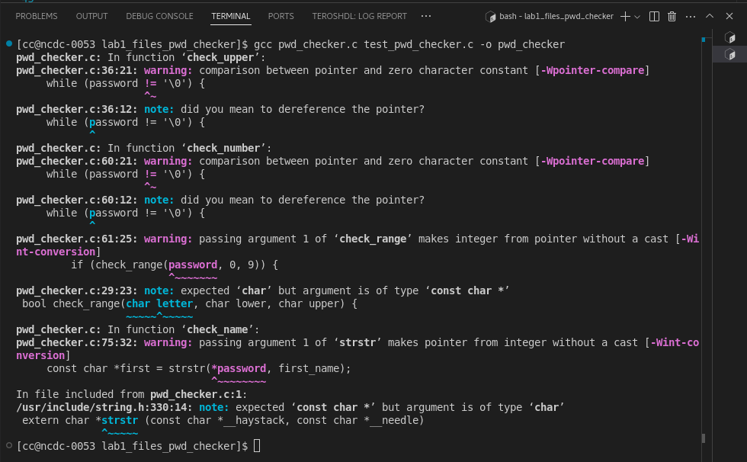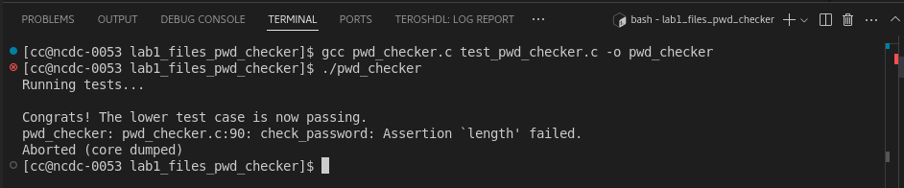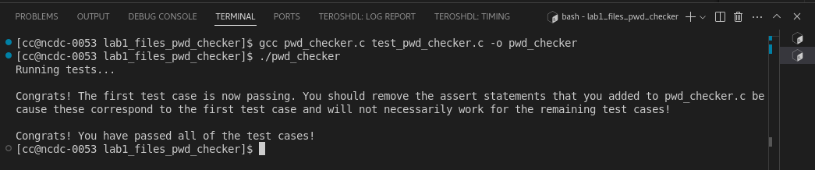

1. **Task 2:**

|  |  |
| --- | --- |
| S.No | Data Type |
| 1 | float |
| 2 | float |
| 3 | int |
| 4 | string |
| 5 | float |
| 6 | string |
| 7 | float |
| 8 | int |
| 9 | float |
| 10 | float |
| 11 | float |

1. **Task 3:**
2. **Task 4:**
3. **Task 5:**
4. **Task 6:**
5. **Critical Analysis: (***Write you critical analysis / conclusion here***)**